CLICK HERE to listen to an Audio interview of Herbert Mai and Helen Mai on October 16, 2022, by Dr. Richards Plavnieks, Chief historian of the Locker of memory project.
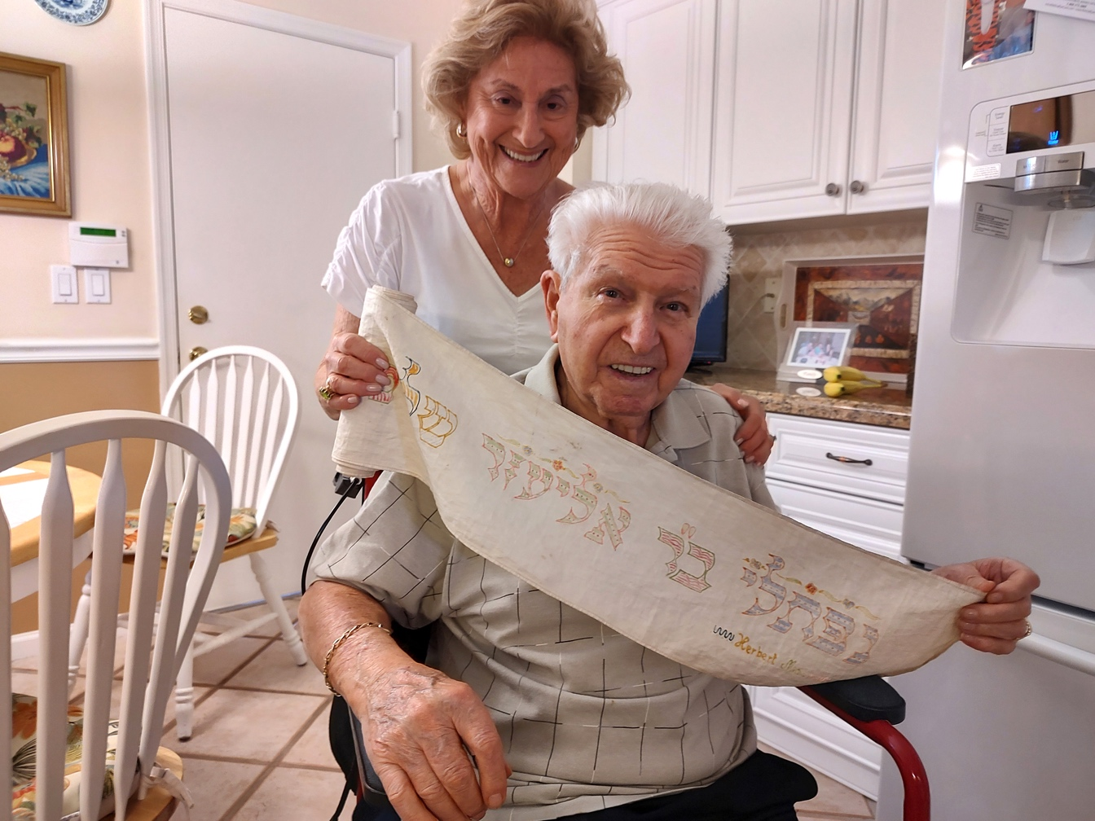

Helen and Herbert Mai holding the Wimpel. Photp: Richards Plavnieks (2022)

The wimpel represents a joyous occasion for families recently giving birth to a male infant. Made from the cloth used to swaddle the infant during the circumcision ceremony, the mother washes the fabric and cuts it into long strips to fashion a sash for wrapping the Torah scrolls together. Embroidered with the child’s name and other elaborate symbols pertaining to the Torah, the bimah within the synagogue, a wedding ceremony with a chuppah, the wimpel joins two major covenants between God and the Jewish people; that of the Torah and circumcision. Tradition requires that the family brings their young son to the synagogue, once he is free of diapers, and dedicates the wimpel to the synagogue. Herbert’s wimpel measures 16 inches long. It was found after the war and returned to Herbert and Helen in the 1970’s.

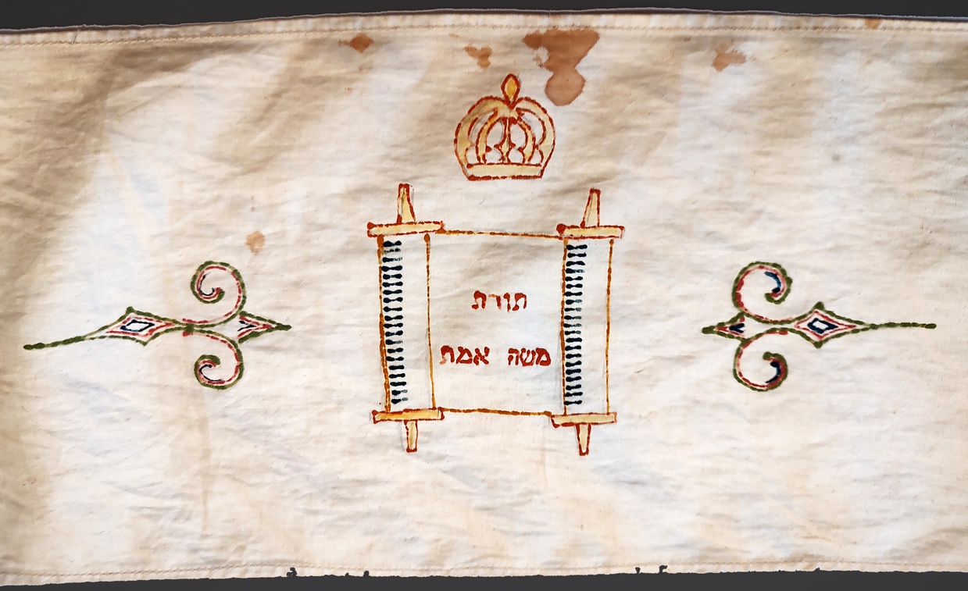

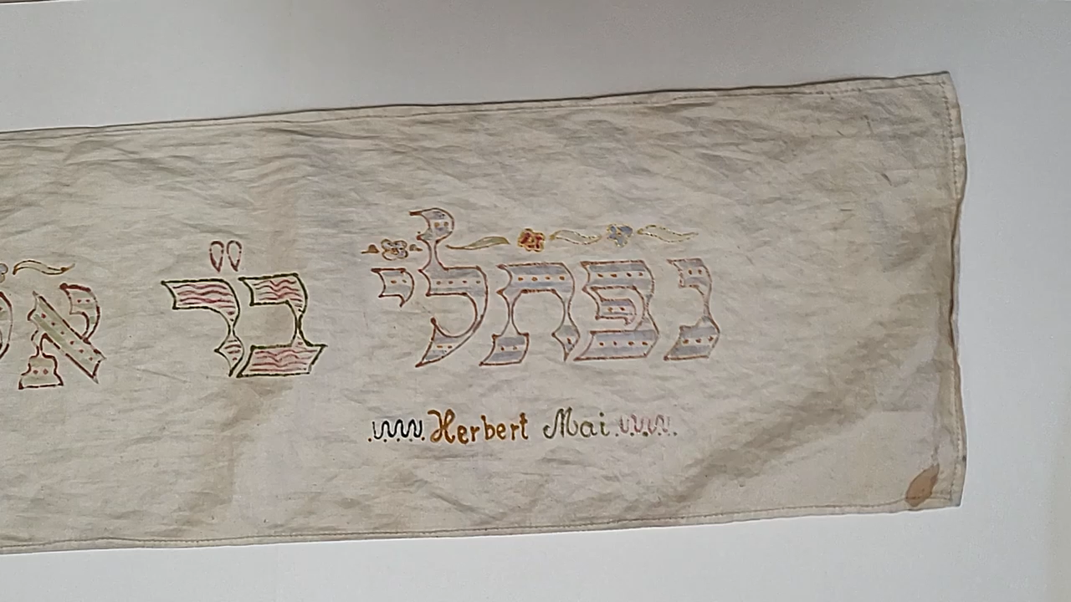
The wImpel, made for Herbert Mai by his mother.

Video by Richards Plavnieks (2022).
Double click on the wimpel and a timeline for watching the video will appear.

